Q.1 How to mirror a root disk?

Answer.

1. Find the disk which to be mirrored with root disk & its size to be equal with root disk.

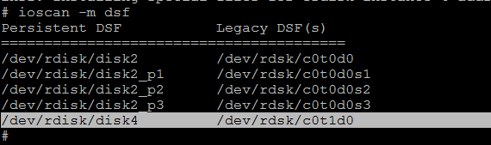

2. Run following command or manually edit in vi /tmp/idf file.

# print '3\nEFI 500MB\nHPUX 100%\nHPSP 400MB' > /tmp/idf

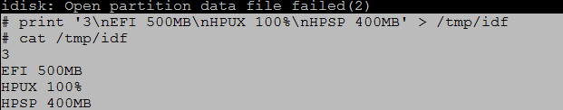

3.

**Use idisk to perform the disk partitioning in the available drive using the file created above.**

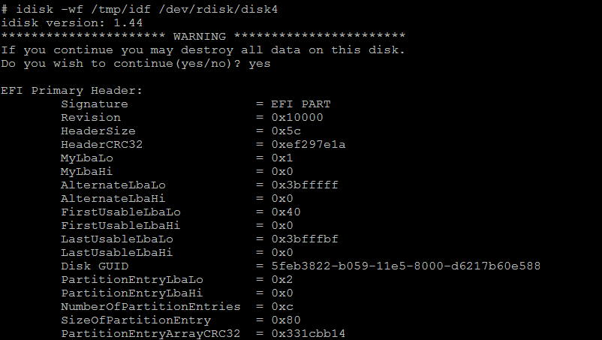

4.

**Use insf command to create device files for new EFI partitions .**

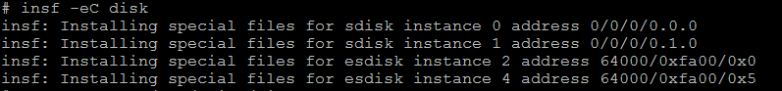

5. Use mkboot to format and populate the newly created EFI partition.

-e for itanium based system

-l for lvm layout



6.

**Change the AUTO file on both boot disks to hpux -lq so the host can boot without quorum if one mirror disk fails.**

**-d for devie file**

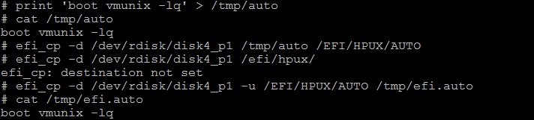

7. use pvcreate command.



8. Add into vg00.



9. create mirroring script.

*-m is used for mirror copy

*if -s is used then it do not synchronize the new mirror copies. This may affect data HA so use lvsync after mirror

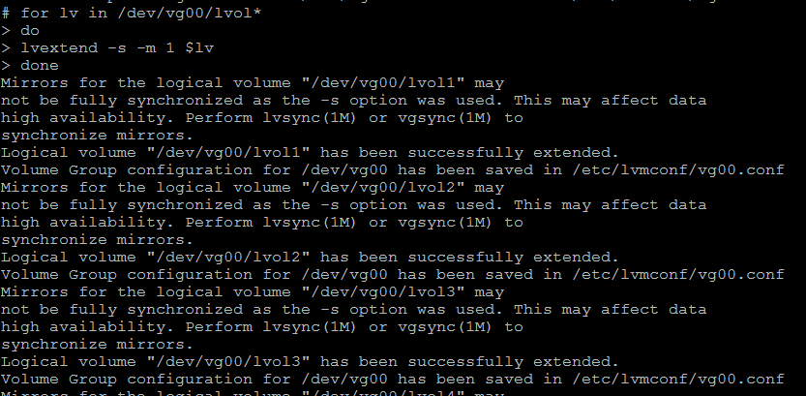

10.

#lvsync –T /dev/vg00/lvol1 /dev/vg00/lvol2 ……….

*T Perform mirror synchronization.

